Task 3: Network Task
1.Get me the IP address of a particular domain (guvi.in).
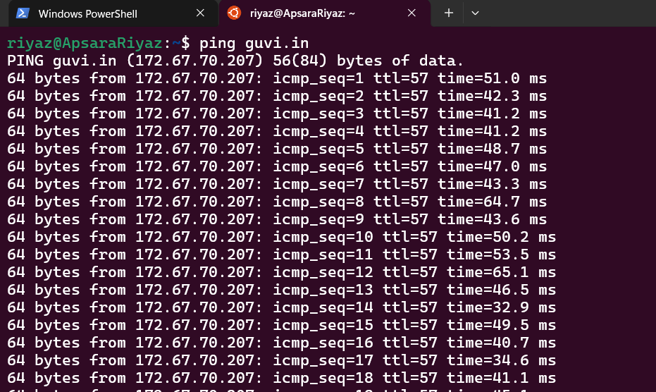
2. How do I find my CPU/memory usage of my server?
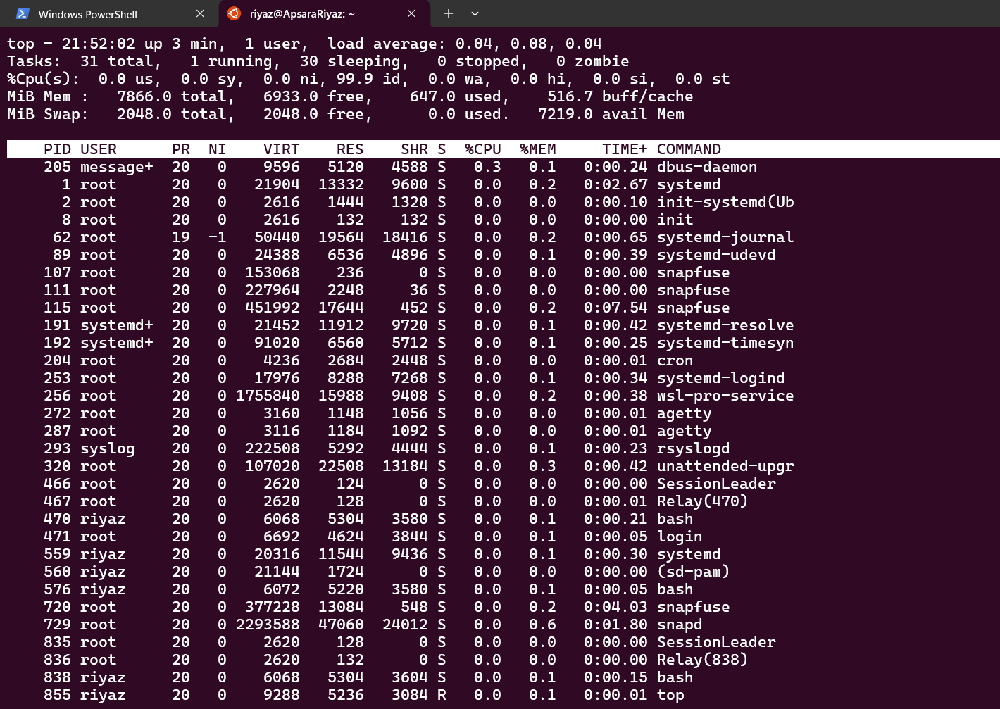
3. Test the connectivity between 2 nodes?
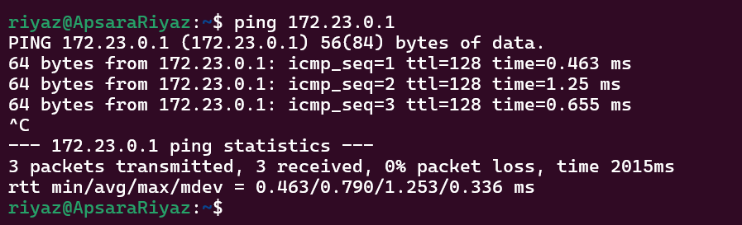
4.
.I have deployed an application in guvi.com:9000, and logs show my app is running, but I’m unable to view the page. Check whether my port is open or not ?
curl http://localhost:9000
netstat -tulnp | grep 9000

